1. Create the following Tables and insert the shown data ( This table will be used in the subsequent Lab sessions )

**Department**

|  |  |  |
| --- | --- | --- |
| **Dept_no** | **Dept_name** | **location** |
| d1 | Research | Dallas |
| d2 | Accounting | Seattle |
| d3 | Marketing | Dallas |

**Employee**

|  |  |  |  |
| --- | --- | --- | --- |
| **emp_no** | **emp_fname** | **emp_lname** | **dept_no** |
| 25348 | Matthew | Smith | d3 |
| 10102 | Ann | Jones | d3 |
| 18316 | John | Barrimore | d1 |
| 29346 | James | James | d2 |

**Project**

|  |  |  |
| --- | --- | --- |
| **project_no** | **project_name** | **Budget** |
| p1 | Apollo | 120000 |
| p2 | Gemini | 95000 |
| p3 | Mercury | 185600 |

**Works_on**

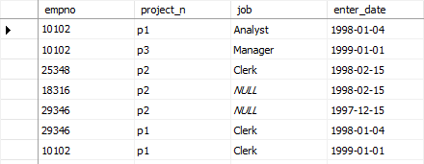

Simple Queries

1. Get the employee numbers for all clerks
2. Get the employee numbers for employees working in project p2, and having employee numbers smaller than 10000. Solve this problem with two different but equivalent SELECT statements.
3. Get the employee numbers for all employees who didn’t enter their project in 1998.
4. Get the employee numbers for all employees who have a leading job( i.e., Analyst or Manager) in project p1
5. Get the enter dates for all employees in project p2 whose jobs have not been determined yet.
6. Get the employee numbers and last names of all employees whose first names contain two letter t’s.
7. Get the employee numbers and first names of all employees whose last names have a letter *o* or *a* as the second character and end with the letters *es.*
8. Get the employee numbers of all employees whose departments are located in Seattle.
9. Group all departments using their locations.
10. Find the biggest employee number.
11. Get the jobs that are done by more than two employees.
12. Find the employee numbers of all employees who are clerks or work for department d3.

**Complex Queries**

1. Get the employee numbers and job titles of all employees working on project Gemini
2. Get the first and last names of all employees that work for departments *Research* or *Accounting.*
3. Get the enter dates of all clerks that belong to the department d1.
4. Get the names of projects on which two or more clerks are working.
5. Get the first and last names of the employees that are manager and that work on project Mercury.
6. Get the first and last names of all employees who entered the project at the same time as at least one other employee.
7. Get the employee numbers of the employees living in the same location and belonging to the same department as one another.
8. Get the employee numbers of all employees belonging to the Marketing department.